Name ____________________________________ Date ________________

What’s the Angle?
Introduction:
Over the course of a year all places on the earth receive equal amounts of sunlight yet climates can vary a great deal depending where you are on earth. The purpose of this lab is to show you how the curvature of the Earth affects the angle at which insolation is striking the planet’s surface, therefore affecting its surface temperature. If the sun is high in the sky, it will strike the earth directly, delivering a strong concentration of light, leading to warm temperatures. If the sun is low in the sky, the light hits earth an angle and it is weak.

In this lab, you will examine exactly how angles affect the concentration of light. You will also examine the relationship between latitude, the location on the Earth and surface temperature.

Part 1
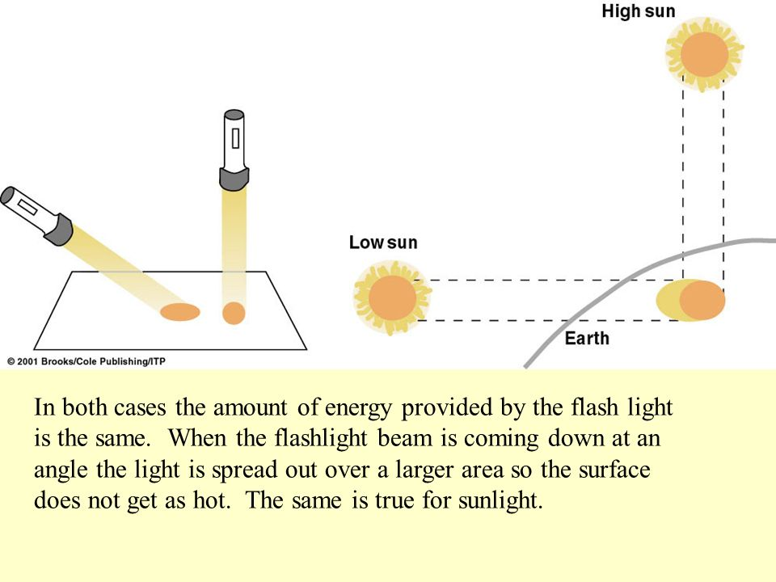

Procedure
- Cut out your protractor
- Mount your flashlight on the stand so that the flashlight bulb is 10cm from the table top.
- Measure the angle between the tabletop and the beam of light from the flashlight.
- Using your graph paper, trace an outline of the central beam of light.
- Count how many squares are in the central beam at this angle. Count more-than-half squares as full squares, and don’t count less than-than-half squares.
- Repeat this process at with two different angles.
- Calculate the strength of the light hitting each square by dividing the power of the flashlight (200 lumens) by how many squares it covered.

Angle of flashlight  (Degrees) | Size of light coverage  (squares) | Strength of light on each square (lumens)

Part 2
Safety:
Exercise extreme caution when using heat lamps. They get very hot!!!
Do not touch them without an oven mitt.
Have your teacher check you set up before you turn on the lamp.

Materials:  classroom globe (at least 30 cm in diameter)  three small thermometers  light source  tape  stopwatch  colored pencils | 40 cm
Procedures:
- Make sure your globe has 3 thermometers set up along the Prime Meridian at the Equator, 45°, and 90°. Each thermometer should be horizontal with the bulb on the right and on the Prime Meridian.
- Set your light source 40 cm from the globe.
- Place your globe in an equinox position in relation to the heat lamp.
- Be sure the lamp is pointing directly on the equator.
- Have your teachers check your set up before turning on the heat lamp.
- Record the temperature before turning on the light in the data table (time 0).
- Turn on the light. Record temperature EVERY MINUTE for 15 minutes for each location. Assign one thermometer per student.
- Graph your data, and answer the questions.

Data:
Time | 0 | 1 | 2 | 3 | 4 | 5 | 6 | 7 | 8 | 9 | 10
Temperature
At the North Pole (90˚)
Temperature
At 45˚

Temperature at the equator (0˚).

Draw a line graph using the temperature data you recorded. Be sure to include a key for each latitude.
Make sure you chose an appropriate title.

TITLE: __________________________________________________________

Temperature (deg. C)

Elapsed Time (min)

Observation Questions:
Why do you need to have the thermometers facing in the same direction?

Why must the sun be shining directly on the equator?

Analysis:
- Define the term insolation.

- What causes the angle of insolation to change as you travel from the equator to the poles on the Earth?

- Which latitude location in your experiment experienced the highest temperature? Why?

- Which latitude location in your experiment experienced the lowest temperature? Why?

- Describe the relationship between latitude location and surface temperature on the Earth.

- Explain how this experiment helped to prove why it is usually cooler in the higher latitudes and warmer near the equator.

- Although the North Pole is tilted toward the sun in the summer, its temperatures are still very cold. How can you explain this?

- Besides the angle of insolation, what is another possible factor that influences the rate of warming of a particular spot on the Earth’s surface?

Application: You’re planning your next beach vacation. You’ve heard about a great spot at (40N, 74W). Name the location. Do you think this is a good choice? ___________ What time of year would you go?

